DIS-Asia-Indus-Zebu Bull

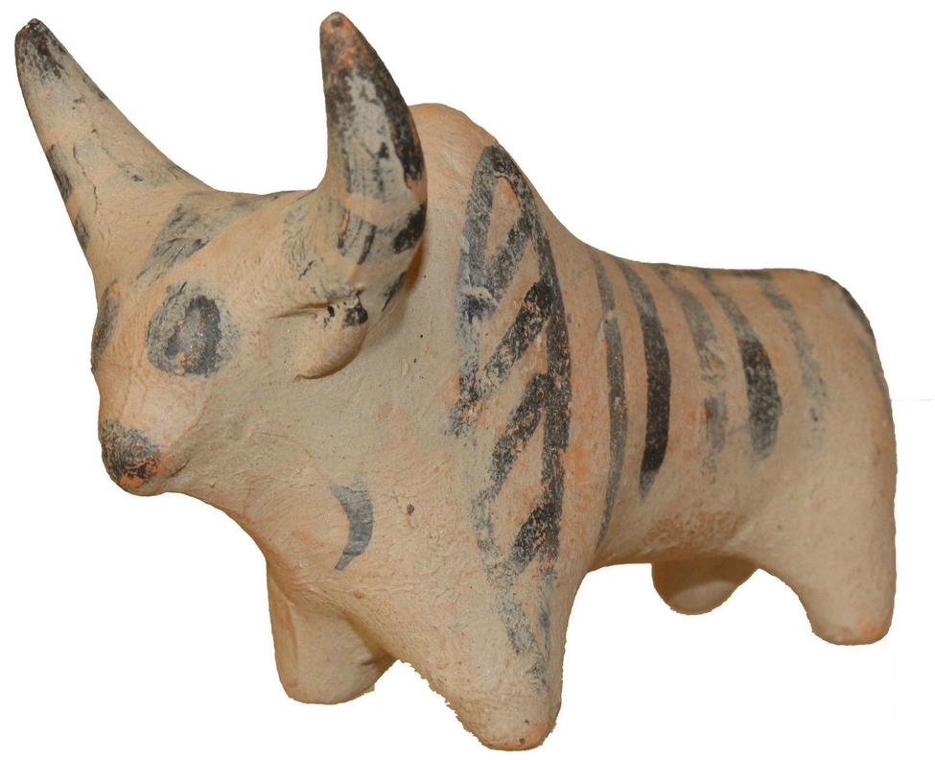

Culture:**Indus Valley (perhaps Mohenjo-Daro) Note striped lozenge marking on front shoulder.**

Date:**2400-2000 B.C.**

Medium:**Terracotta**

Condition: **Intact**

Provenance:**Ex: Important American private collection, 1970's**

Price: US $990.00

**Weight : 96gm., Size : 93mm x 69mm x 47mm**